Experiment 8: Iterative Deepening Search

Aim:
To implement Iterative Deepening Search (IDS), a search strategy that repeatedly performs Depth-Limited Search (DLS) with increasing depth limits until the goal node is found.

Algorithm:
Iterative Deepening Search (IDS)
- Start with depth limit = 0
- Perform Depth-Limited Search (DLS) with the current depth limit
- If goal is found → STOP
- Else increase depth limit by 1
- Repeat until goal is found

Depth-Limited Search (DLS)
- If depth limit = 0 → return failure
- If current node = goal → return success
- For each child of current node:
  - Recursively call DLS with depth limit − 1
- If any recursive call succeeds → return success
- Else return failure

Flowchart:

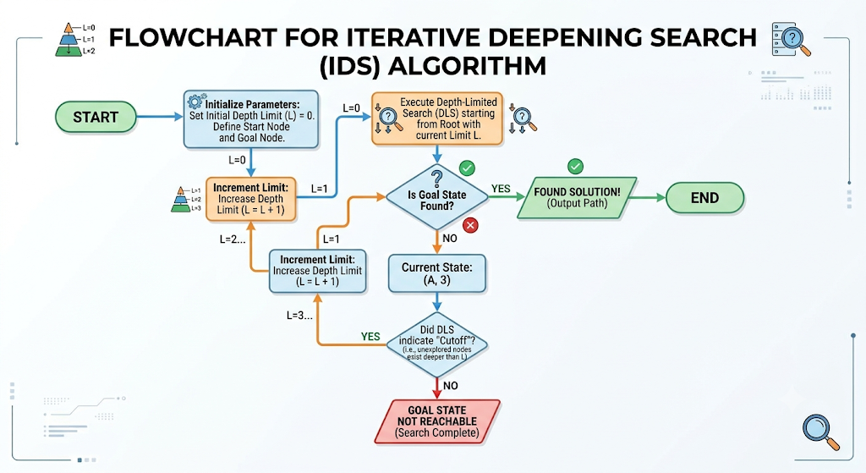

Source Code:

def dfs_limited(node, goal, depth_limit, graph): if depth_limit == 0:
return Non

if node == goal: return [node]

for child in graph.get(node, []):
result = dfs_limited(child, goal, depth_limit - 1, graph) if result is not None:
return [node] + result

return None

def iterative_deepening_search(start, goal, graph): depth = 0
while True:
print(f"Trying depth limit: {depth}")
result = dfs_limited(start, goal, depth, graph) if result is not None:
return result depth += 1

# Example graph graph = {
'A': ['B', 'C'],
'B': ['D', 'E'],
'C': ['F'],
'D': [],
'E': ['G']

'F': [],
'G': []
}

# Run IDS
path = iterative_deepening_search('A', 'G', graph) print("Goal found! Path:", path)

Output:

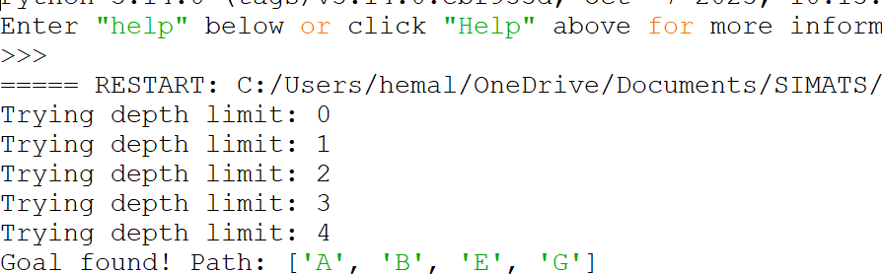

Result:
The IDS algorithm successfully finds the goal node G starting from A, exploring depth levels one by one. The final path returned is:
A → B → E → G
This confirms that IDS correctly performs repeated depth-limited searches and finds the optimal depth at which the goal exist

